***Elect* Department of Electronics and Telecommunication Engineering**

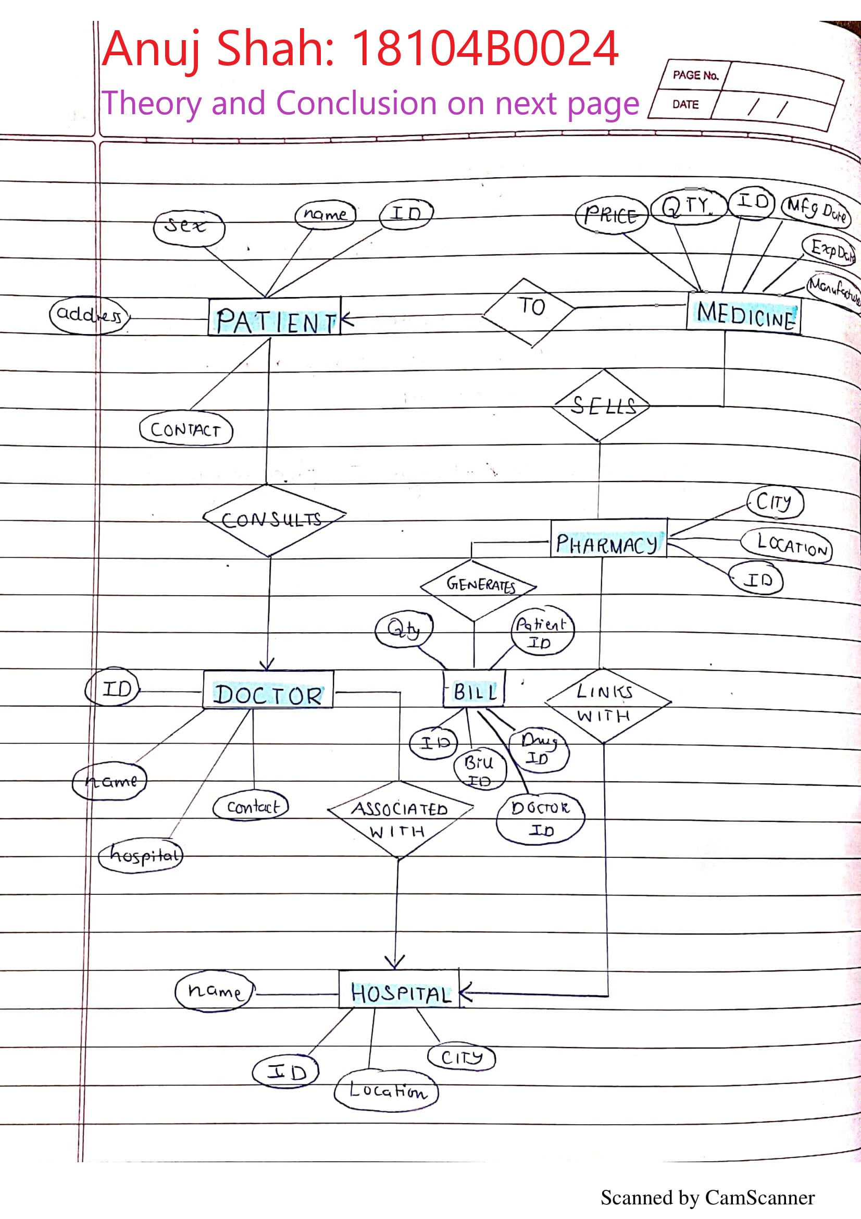

|  |  |  |
| --- | --- | --- |
| Semester | T.E. Semester VI – EXTC Engineering | |
| Subject | Computer Communication Network (CCN) | |
| Laboratory Teacher: | Prof. Santosh Tamboli | |
| Laboratory | MS-Teams online | |
| Student Name | Anuj Shah | |
| Roll Number | 18104B0024 | |
| Grade and Subject Teacher’s Signature |  |  |

|  |  |  |
| --- | --- | --- |
| Experiment Number | 01 | |
| Experiment Title | ER diagram | |
| Aim | To study and draw ER diagram | |
| Resources / Apparatus Required | Hardware: None | Software: None |
| Theory: | An entity-relationship model (or ER model) describes interrelated things of interest in a specific domain of knowledge. A basic ER model is composed of entity types (which classify the things of interest) and specifies relationships that can exist between entities (instances of those entity types).  In software engineering, an ER model is commonly formed to represent things a business needs to remember in order to perform business processes. Consequently, the ER model becomes an abstract data model, that defines a data or information structure which can be implemented in a database, typically a relational database.  Entity–relationship modeling was developed for database and design by Peter Chen and published in a 1976 paper, with variants of the idea existing previously. Some ER models show super and subtype entities connected by generalization-specialization relationships, and an ER model can be used also in the specification of domain-specific ontologies. | |
| Conclusion: | In this experiment, we learned what an ER (entity-relationship) diagram is, and we drew the ER diagram for a Medical Inventory. | |
|  |  | |